Title of a paper

(Times New Roman 14)

Name Surname[1], Name Surname [2]

Abstract

The abstract should be written in Slovak/Czech/English. (max. 15 lines)

Key words

Keyword1, Keyword2, Keyword3, (max. 6 keywords)

# Introduction (automatically numbered, Space Before: 12 b, Space Behind: 6b)

Text paragraphs should have an initial indent of 1 cm. The manuscript should meet the following requirements:

• Paper size: A4

• Edges: all – 25 mm,

• Font size: main text – 12 pt,

• Line spacing – 1 (simple),

• Space: Before: 0 b, Behind: 0 b,

• Alignment: by margins,

• Breaks: Left: 0, Right: 0, Special: 0,

• References in the text should follow this format: (Surname, year) (Friedman, 1970).

Do not leave a free line after individual numbered parts of the article.

# Title of chapter (automatically numbered, Space Before: 12 b, Space Behind: 6b)

Please follow the instructions in the “Introduction”.

* 1. **Title of the subsection (automatically numbered, Space Before: 12 b, Space Behind: 6b)**

Please follow the instructions in the “Introduction”.

**Formulas** should be centered and continuously numbered (numbering is on the right in round brackets). If there are no references to formulas in the text, formula numbering is optional. Use the equation editor to write formulas. Leave one free line before and after the formula.

$y^{*}=exp\left(\frac{α_{0}+α_{1}ln⁡(NoP)}{1-α_{2}}\right)$ (1)

**Tables** should be centered, consecutively numbered, and references to tables should be included in the article. Tables should not extend beyond the edges of the page. Leave one free line before and after the table.

Tab. 1 Table name (Times New Roman 12, Italic; center alignment)

| **Testing Global Null Hypothesis: BETA=0** | | | | | | |
| --- | --- | --- | --- | --- | --- | --- |
|  | **SR** | | | **PL** | | |
| **Test** | **Chi-Square** | **DF** | **Pr > ChiSq** | **Chi-Square** | **DF** | **Pr > ChiSq** |
| **Likelihood Ratio** | 810.1 | 26 | <.0001 | 2098.4 | 28 | <.0001 |
| **Score** | 816.7 | 26 | <.0001 | 1954.3 | 28 | <.0001 |
| **Wald** | 654.7 | 26 | <.0001 | 1600.7 | 28 | <.0001 |

Source: ...... (Times New Roman 10; center alignment, style: Source)

**Images (graphs)** should be centered, consecutively numbered, and the article should contain references to images. Images should not extend beyond the edges of the page. Leave one free line before and after the image.

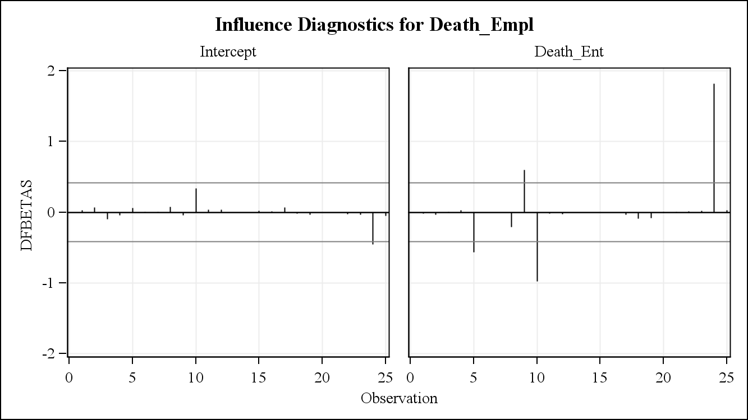

Fig. 1 Name of the image *(Times New Roman 12, Italic; center alignment)*

Source: ...... (Times New Roman 10; alignment, style: Source)

# Part name (automatically numbered, Space Before: 12 b, Space Behind: 6b)

Follow the instructions above.

# Conclusion (automatically numbered, Space Before: 12 b, Space Behind: 6b)

This section should contain the conclusion of the article. Follow all instructions for writing a post. In case of non-compliance with the editing instructions, the publisher reserves the right not to publish such a contribution.

**Literature**

Literature must be arranged alphabetically.

1. University / institution, faculty, department, address, e-mail (1st author). Footnotes (Times New Roman, size 10, alingn - style: Footnote).
2. University / institution, faculty, department, address, e-mail (2nd author).